BUSINESS AND RESIDENTIAL NOTICE TEMPLATE
The applicant may add project information to this template but must not remove or change any bolded language (other than changing fonts or removing bolding).

Business and Residential Notice
In Treatment Area In ¼ Mile Notification Area

Distribution Date: Date notices mailed or delivered

Water body will be treated with name type of product (e.g., aquatic herbicides, algaecides, bacterial products, etc.) on or between treatment dates.

Product(s) planned for use: list product names

Active ingredient(s): list the active ingredients

Plants/Algae targeted: describe what will be treated and why

Location of treatment(s): describe locations or include a map
The applicator will post signs in the treated and potentially affected areas no more than 48 hours prior to treatment. The signs will describe any water use restrictions or advisories.

If you are withdrawing water for potable or domestic water use, livestock watering, or irrigation, and have no alternate water source, please contact name of applicator at phone number or e-mail to arrange an alternate water supply.
Note: Business and residential notification only goes ¼ mile from each treatment site. Check the product label to ensure that treatment does not impact potable water users more than ¼ mile from treatment area.

If you want additional notification prior to treatment, or have further questions, please contact me using the information above. Optional: include contact information for the sponsor here.

This herbicide treatment is regulated under a permit issued by the Washington State Department of Ecology. Permit No. applicator to enter the permit coverage number
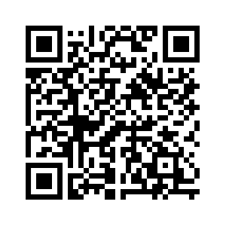
Scan with QR reader to go
to permit web page

